# Dream Scheme

**1. Game overview**

Platform：PC

Controler：mouse

Game type：Word Adventure Game

**The way to fight**

Show the collected items

# 2. Game goal

Explore the dream, collect emotional fragments, untangle the causes of deep dream, and try to get out of the dream.

# 3. Game background

Oliver is a twenty-six-year-old young man with advanced leukemia, who knew he was dying, so he took the hospital's advice and agreed to inject ***Special Psychedelics*** to spend the rest of his life in a dream. Under the action of medicine, Oliver will only have very few memories, Oliver began to explore the dream, constantly retrieve the lost memory, and try to get out of the dream.

Oliver is a typical antisocial personality, his mother died unexpectedly when the protagonist was young, his father was very indifferent to him, his best friend because of his mistakes and suicide, he thought that life is only malicious.

Leukemia treatment is very expensive, and the chances of survival is very low, Oliver can not pay for treatment, so can only choose to inject ***Special Psychedelics*** before death, ***Special Psychedelics*** is a product of research and development, Oliver signed an agreement is a clinical trial

## Characters introduction

### Father

Oliver grew up with his father, who had always been very cold in his impressions and rarely communicated with him.

### Mother

Oliver loved his mother best as a child, but her mother died in an accident when Oliver was very young, and Oliver remembers it because of his father's mistakes.

### Lisa

Lisa is Oliver's best friend. Oliver had few friends in high school and would only relax when he was with Lisa.

### Teacher

Oliver's strict and stubborn head teacher, in Oliver's memory, the head teacher did not like him.

### Classmates

In Oliver's memory due to Oliver's introverted, the class of students are likely to exclude Oliver, and Oliver's relationship is very bad.

## Emotion introduction

### Detest

From the father's choice，Oliver thought his mother had died because of his father's wrong choice.

Relative emotion：Father’s love

### Rage

The manslaughter from the police broke out after learning the truth about the mother's death.

Relative emotion：Mother’s love

### Remorse

From the guilt of Lisa's suicide.

Relative emotion：Friendship

### Fear

From childhood fear of ghosts.

Relative emotion：Courage

### Depressed

from life's malice towards Oliver.

Relative emotion：Cheerful

## Interesting point

# In the tense plot appears, the game randomly appears electrocardiogram sound, ventilator sound, fuzzy small voice communication sound.

# 4. Map explanation

## Dream Building

The virtual building that carries the whole dream map, how rich the human heart is, how big the building is.

## Hall

## Entering the starting point of a dream, it looks like a hotel reception hall.

## Accommodation area

Accommodation and rest are available at the hotel and can be used for archiving.

## Cinema

A place for film screenings.

## Wilderness

A place in the wilderness where birds don't give a shit.

## Hills

The scenery is very good in the wild.

## Home

Where Oliver grew up, it is crowded but full of memories.

## School

Oliver's high school.

## Classroom

Oliver high school classroom.

## The sea of clouds on the top of the mountain

The favorite place for Oliver's best friend Lisa.

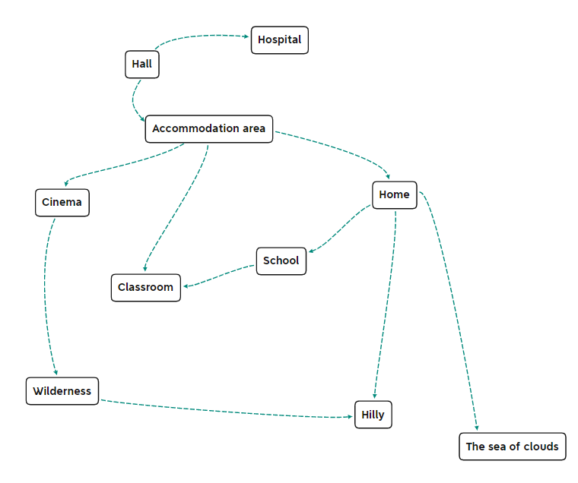

# 5. Items explanation

## A letter of condolence to father

The leader apologized to his father for the sniper's mistake in hitting his mother, and asked him to end his undercover job early and retire directly

## Father's dressing gown

The robes that my father often wore were thick and large and very warm.

## Small cards that have been repaired

Oliver's favorite little card as a child, with tinkering marks on it.

## Mother's last words

All these years your father lived a hard life, do not blame him, to live a good life, I love you.

## Mother's diary

Mother actually knew her father's undercover work, but did not puncture, but silently cooperate. The mother was very supportive of her father's approach: to abandon the interests of the small family for the benefit of the public.

## The resignation of the police officer

The police officer who killed his mother by mistake was actually his father's old subordinate, and after the case he submitted his resignation directly. He made it clear that he was afraid to continue the job, but that he would continue to fight drug-related crime elsewhere.

## The last letter of Lisa

Lisa said she understood Oliver's pain of losing her mother, but she was in pain at the time and couldn't comfort the protagonist again. She said they had been depressed and miserable, but every thought of the past with Oliver will ease a little. Finally chose to jump the cliff is to be free, and did not blame Oliver.

## Lisa’s cat

The kitten, who had been with Lisa for six years, was so clever that it disappeared after Lisa jumped off the cliff.

## Self-portrait

A self-portrait by Lisa and Oliver, it’s a testament to their friendship.

## Political materialism knowledge

Ghosts don't exist.

## Little pillow

In order to appease Oliver, who was afraid of a ghost and couldn't sleep, mother bought a small pillow, which was said to hold him so that the ghost would not come near.

## A page of the journal

Oliver grew up trying to overcome his fear of ghosts, imagining ghosts around him again and again, then calming himself down and repeatedly stimulating himself in this way until he was no longer afraid. The diary page records the number of times they recall, and the top is covered with strokes.

## A letter from the police officer

The police officer later became a private investigator, specializing in the pursuit of drug lords, over the years successfully captured a lot of drug lords. The letter was written to tell Oliver’s father that the gang had been found by him and had all been arrested.

## Oliver’s footprints

When Oliver was on the full moon, mother printed his footprints on the paper with red mud on his feet.

## A bunch of hair from Oliver

Oliver’s tresses when he was one year old.

# Memory

## Mother's death

The gangsters burst into the house and took the mother hostage. The father dialed a telephone first and then confronted the gangster.

Suddenly outside the confrontation, the mother fell to the ground, the father rushed to subdue the gangsters.

## Father’s love

Oliver often quilts at night, his father will cover the quilt with a thick dressing gown, keep warm and press the quilt, once Oliver in half asleep half awake to see, left warm in heart.

## Father’s choice

The gangsters burst into the house and took the mother hostage. The gangsters asked the father to choose one to survive with Oliver and his mother, and the other to be shot. If you don't make a choice, both of them shoot. The father chose Oliver, and then shots rang out outside the house.

## Oliver’s little card

Oliver's favorite little card as a child, students want to grab a look, when the fight was torn, Oliver cried for a long time.

## Mother's sleeping song

To appease Oliver, who couldn't sleep for fear of ghosts, her mother bought a small pillow and put the protagonist to sleep, and she lay on Oliver's side, gently stroking and singing.

## Lisa's family accident

Lisa's mother was very ill, and she came to the protagonist hoping for comfort, but by then Oliver's mother had just died

Oliver quivered: At least your mother is still there, my mother is gone

Lisa and Oliver never met again when Lisa's mother died

A few months later Oliver heard that Lisa had committed suicide

# Ending

Single-choice questions:

Are you really leaving?

Maybe going out is death, do you insist on leaving?

Even if the world treats you hypocritically, do you insist on leaving?

Even if everything is business as usual outside, no one cares about you, do you insist on leaving?

Even if all this is your guess, originally did not exist, you insist on leaving?

All five questions choose "yes" to get out of the dream.

## Ending 1：

Oliver opened his eyes and saw a lot of people sitting in front of the hospital bed, father, Lisa, teacher, classmate, they were all there, Oliver struggled to sit up, smiling at everyone.

## Ending 2：

Oliver opened his eyes to see his father sitting in front of the hospital bed, his father tearfully watched Oliver, Oliver smiled, silently said "I love you", and then the electrocardiogram device sounded an alarm, the main character died.

## Ending 3：

Oliver heard his own rapid breathing, opened his eyes to see the hospital bed empty, electrocardiogram instruments began to sound the alarm, the eyes gradually blurred, vaguely saw the doctor with the nurse rushed into the ICU, electrocardiogram gradually turned into a straight line, and then Oliver closed his eyes forever.